CHEF - AI Assisted Prototype
Convenient, Healthy, Economical Food
Prepared by: Ravi Kumar Agarwal

Table of Contents
- Problem Statement
- Solution
- Prototype Overview
- Prototype URL
- QR Code Access
- Home Page
- Account Sign-Up Page
- Sign-Up Screen
- Invalid Credentials Error
- Admin Dashboard
- Database API Integration
- Database Structure
- Pre-Orders Table
- User Roles Table
- Pages Created

Problem Statement
People living in large metropolitan cities often struggle to find food that is healthy, affordable, and convenient all at the same time. Most fast-food options fall into only one or two of these categories:
Some are affordable but unhealthy.
Others are healthy but too expensive.
A few may be healthy and affordable, but not convenient for people with busy working schedules.
Solution
To address this gap, CHEF, which stands for Convenient, Healthy, Economical Food, is testing a solution by launching a food cart outside the Indiana University campus. They created a simple MVP prototype that allows customers to scan a QR code and order from three healthy salad options directly from their phone.
This AI-assisted prototype aims to validate whether their concept can meet the needs of people seeking quick, nutritious, and reasonably priced meals.
Prototype Overview
The user can click the "Pre-order Now" button for any of the three salad options. In the background, every click is recorded and can later be viewed in the Admin Dashboard.
This data helps the CHEF team test, evaluate, and refine their product or concept before moving into full-scale development.
Prototype URL
The prototype is accessible at: https://sprout-ready-meals.lovable.app/
QR Code Access
The following QR code could be displayed at a conference/event, where people can use their phones to scan the QR code which would take them to the CHEF prototype landing page.

Figure 1: QR Code for accessing the CHEF prototype
Home Page
The home page displays the three salad options available for pre-order, with clear images and descriptions of each healthy meal choice.
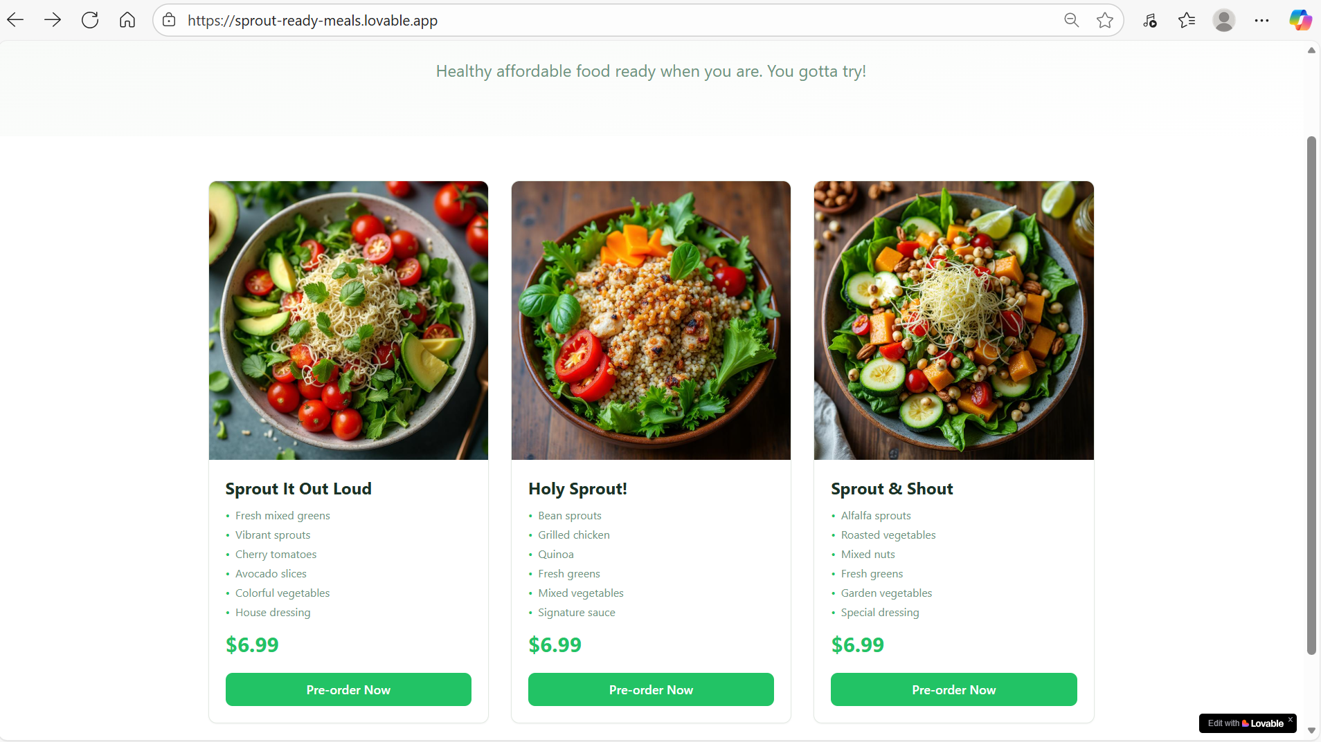
Figure 2: Home page of the CHEF website showing salad options
Account Sign-Up Page
First-time users can create an account to access the ordering system and track their preferences.
Sign-Up Screen
The registration interface allows new users to create their account credentials.

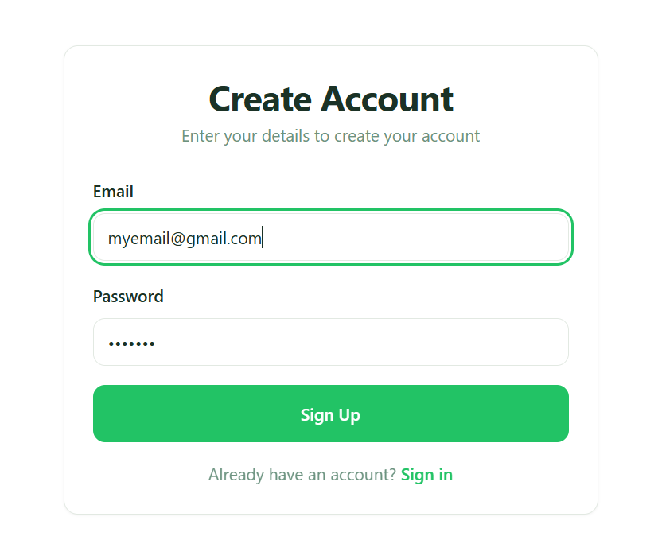
Figure 3: Sign-up screen for new user registration
Invalid Credentials Error
When a user tries to log in with invalid credentials, an error is thrown that says "invalid credentials" to inform the user of the authentication failure.
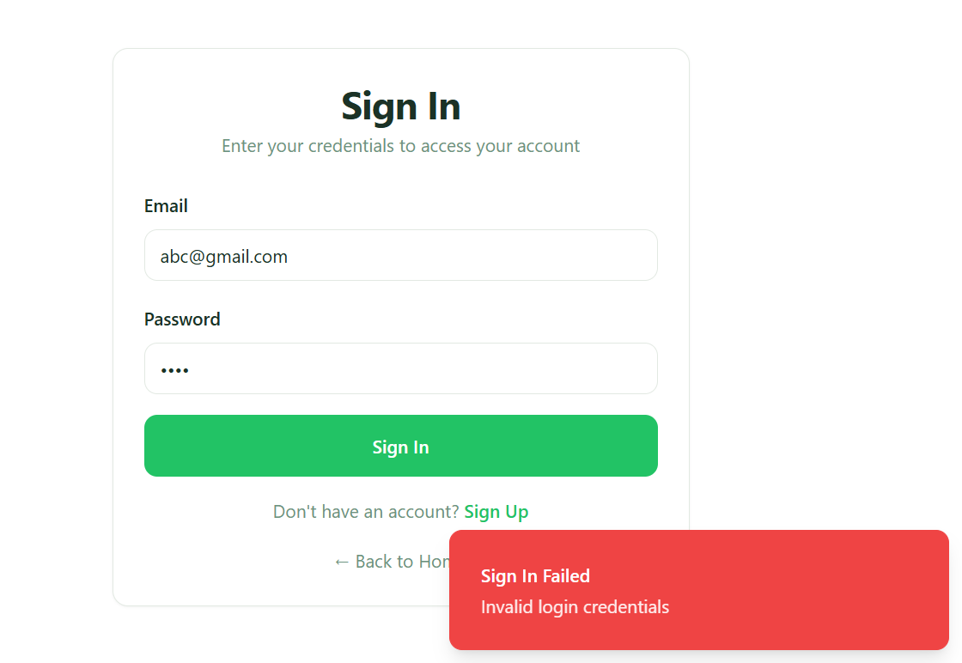
Figure 4: Invalid credentials error message
Admin Dashboard
The number of clicks on the pre-order now button for each salad option is tracked and displayed on the admin dashboard. This provides real-time analytics on customer preferences and engagement.
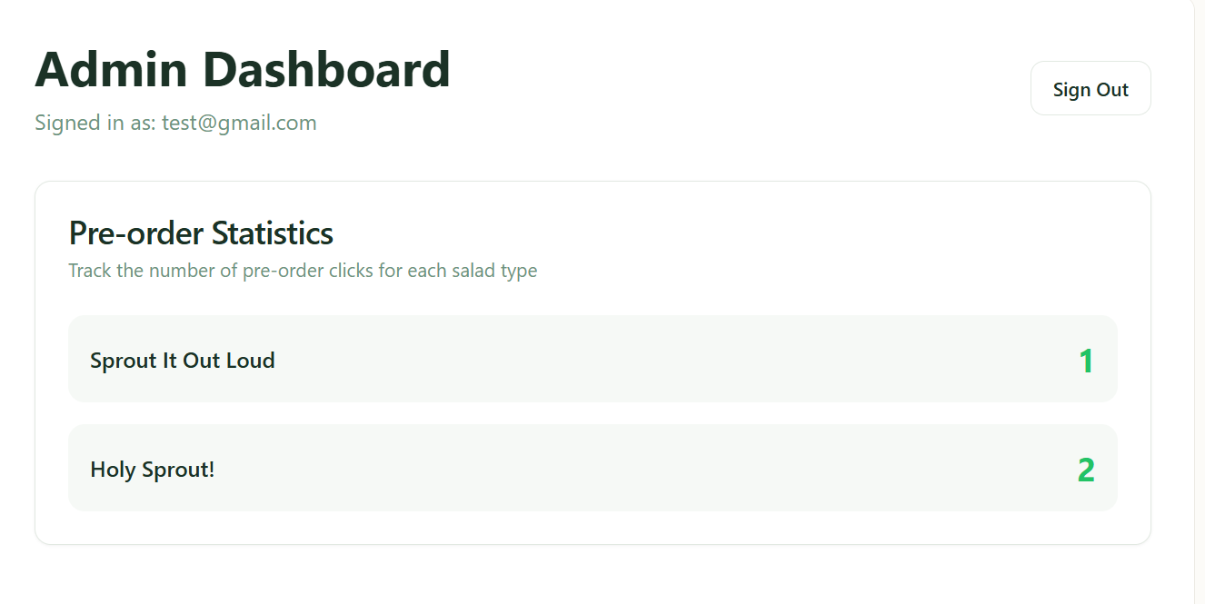
Figure 5: Admin dashboard showing pre-order analytics
Database API Integration
Each click on the pre-order button for each salad type is stored in the database, and from the database, it is displayed on the admin dashboard via the GET API.
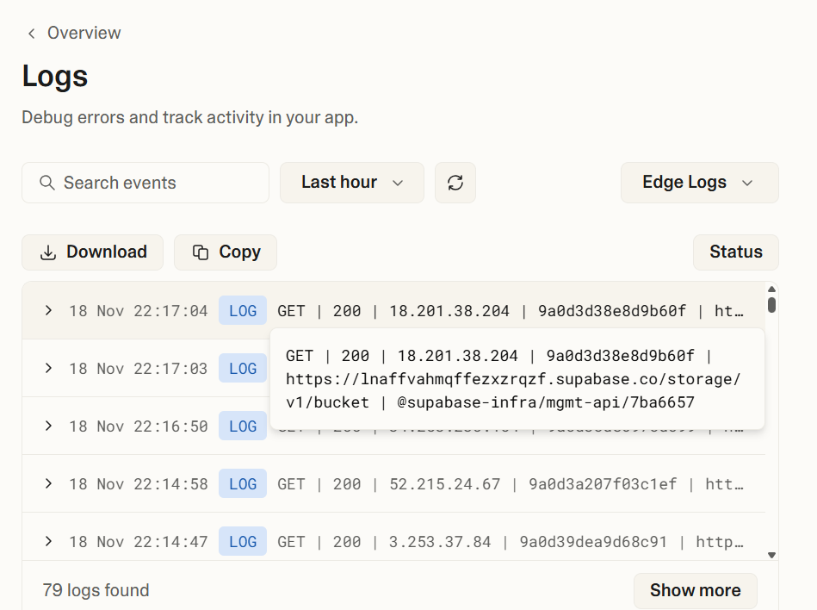
Figure 6: Database API integration for retrieving pre-order data
Database Structure
The database has two tables: (i) pre_orders and (ii) user_roles.
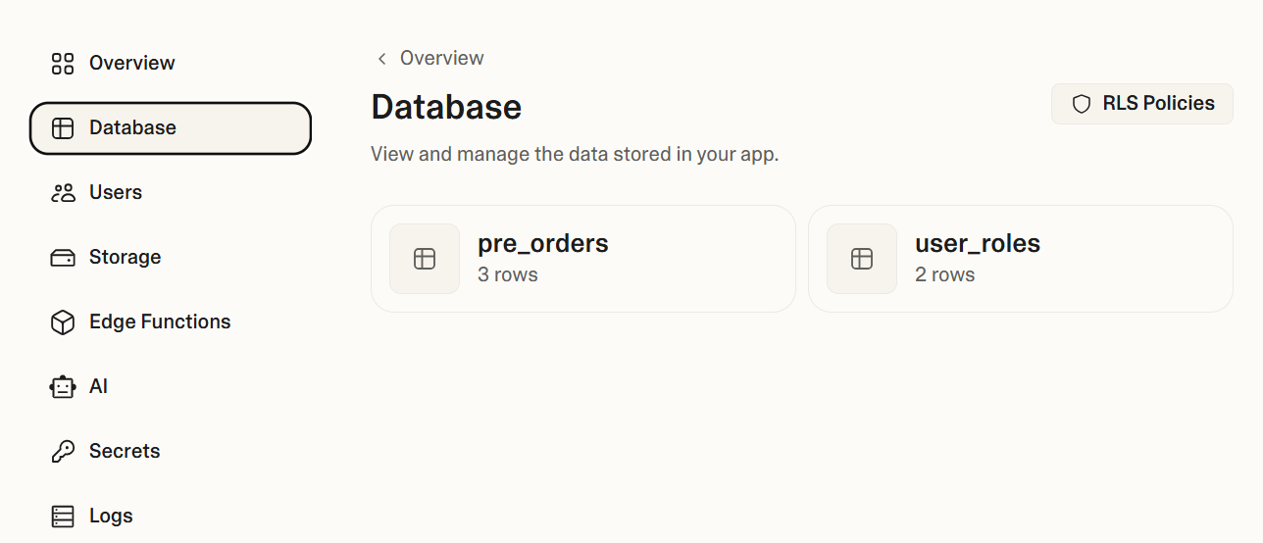
Figure 7: Database structure showing both tables
Pre-Orders Table
The pre_orders table columns include:
id - unique identifier for each pre-order
salad_name - name of the selected salad option
clicked_at - timestamp of when the pre-order button was clicked

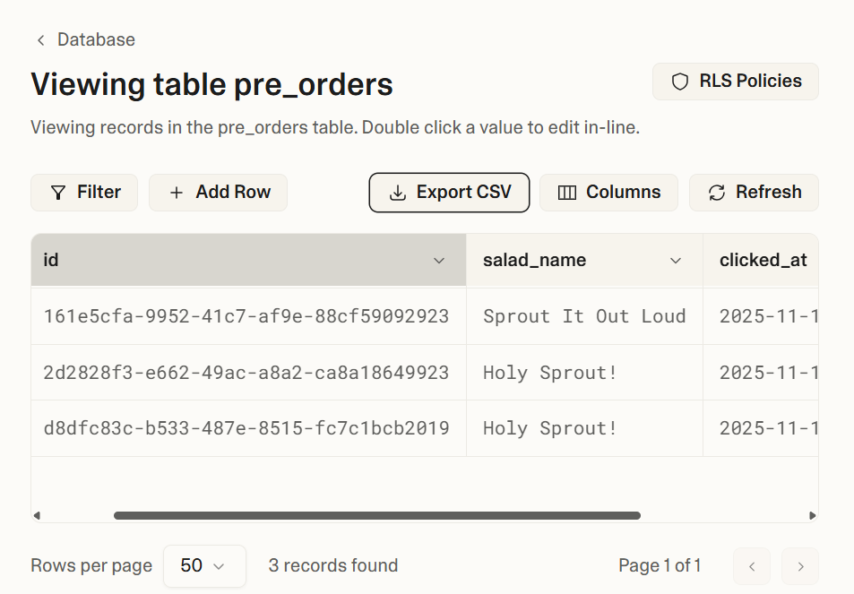

Figure 8: Pre-orders table structure and sample data
User Roles Table
The user_roles table columns include:
id - unique identifier for each role assignment
user_id - reference to the user
role - assigned role (e.g., admin, customer)
created_at - timestamp of role creation
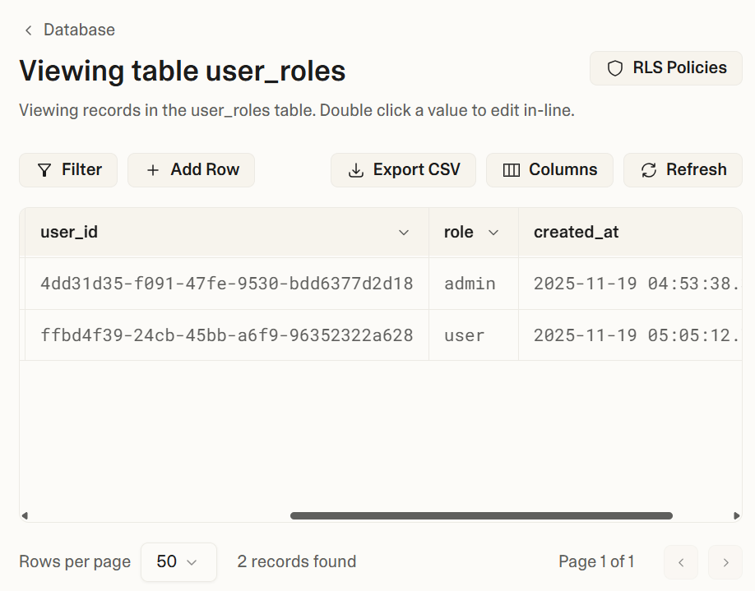
Figure 9: User roles table structure
Pages Created
The following pages were created as part of the prototype:
/signin - Login page
https://sprout-ready-meals.lovable.app/signin

/signup - Registration
https://sprout-ready-meals.lovable.app/signup

/admin - Analytics dashboard (admin-only)
https://sprout-ready-meals.lovable.app/admin
(this is accessible only after login with valid admin credentials)

Thank You
Thank you for reading this document. I appreciate your time and attention to the CHEF AI-assisted prototype project. This innovative solution demonstrates how technology can bridge the gap between health, affordability, and convenience in urban food services.

